TEAM ID : PNT2022TMID14986

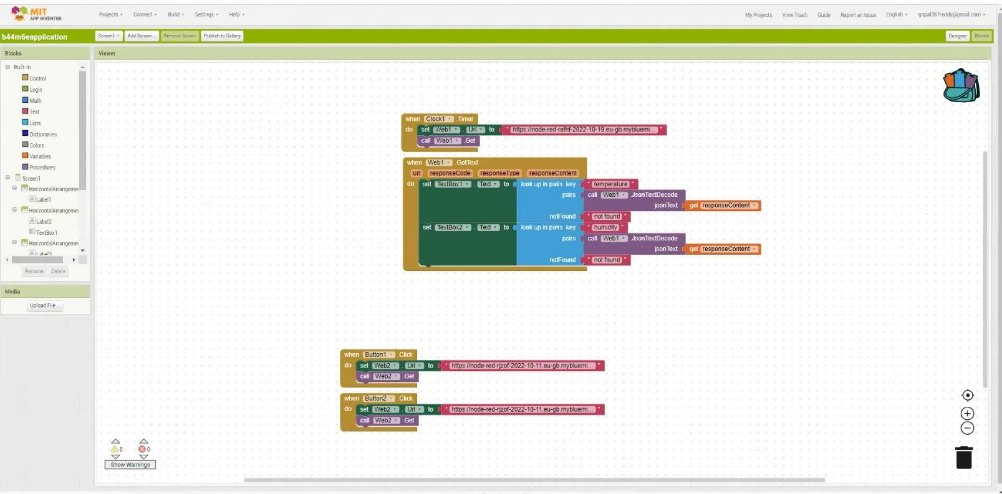Testing the application using the required inputs:

